Database - MySQL

**Task :- Design a DB model for Guvi Zen class**

**--Student Collection**

**--Batch Collection**

**--Task Collection**

**--Mentor Collection**

**Batch table**

query to create batch table:-

**----create table batch(batch_id int(5),auto increment, primary key(batch_id), batch_name varchar(50));**

query to insert data into the batch table:-

**----INSERT INTO `batch` (`batch_id`, `batch_name`) VALUES ('1', 'B31WE_ENGLISH');**

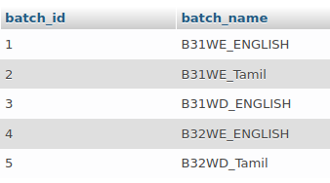

**Students table**

query to create Students table:-

**-----CREATE TABLE Students(stu_id int(5), primary key(stu_id), student_name varchar(50), batch_id int, FOREIGN KEY (batch_id) REFERENCES batch(batch_id))**

query to insert data into the Students table:-

**-----INSERT into Students(`stu_id`, `student_name`, `batch_id`) VALUES ('002', 'Varun',3);**

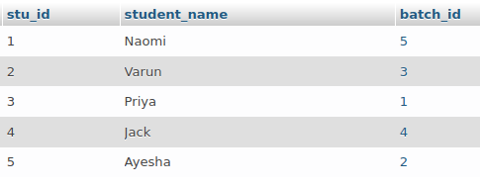

**Mentor table**

query to create Mentor table:-

**-----CREATE TABLE Mentor(M_id int(5), primary key(M_id), Mentor_name varchar(50), batch_id int, FOREIGN KEY (batch_id) REFERENCES batch(batch_id))**

query to insert data into the Students table:-

**----INSERT into Mentor(`M_id`, `Mentor_name`, `batch_id`) VALUES ('991', 'Poonam',2)**

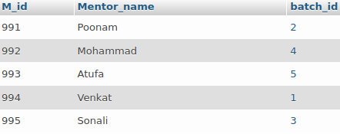

**Task table**

query to create Task table:-

**-----CREATE TABLE Tasks(T_id int(5), primary key(T_id), Task_Title varchar(50), batch_id int, FOREIGN KEY (batch_id) REFERENCES batch(batch_id))**

query to insert data into the Students table:-

**INSERT into Tasks(`T_id`, `task_Title`, `batch_id`) VALUES ('02', 'Design DB model for Guvi ',3);**

